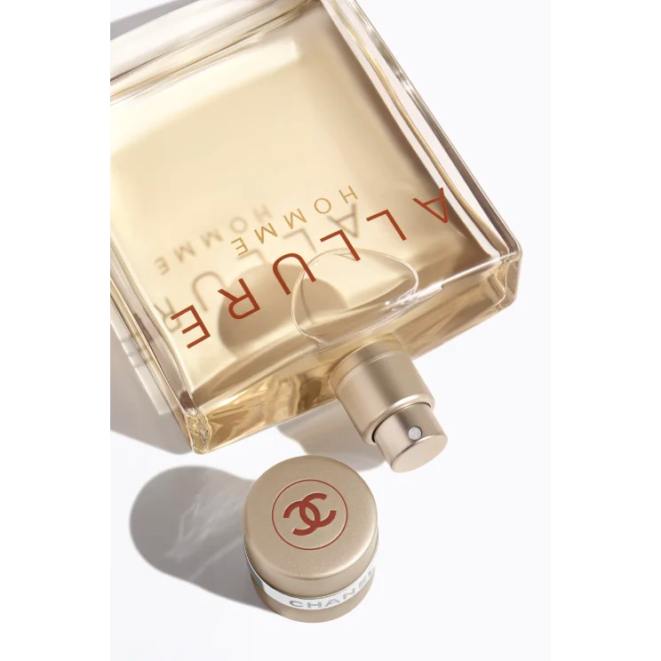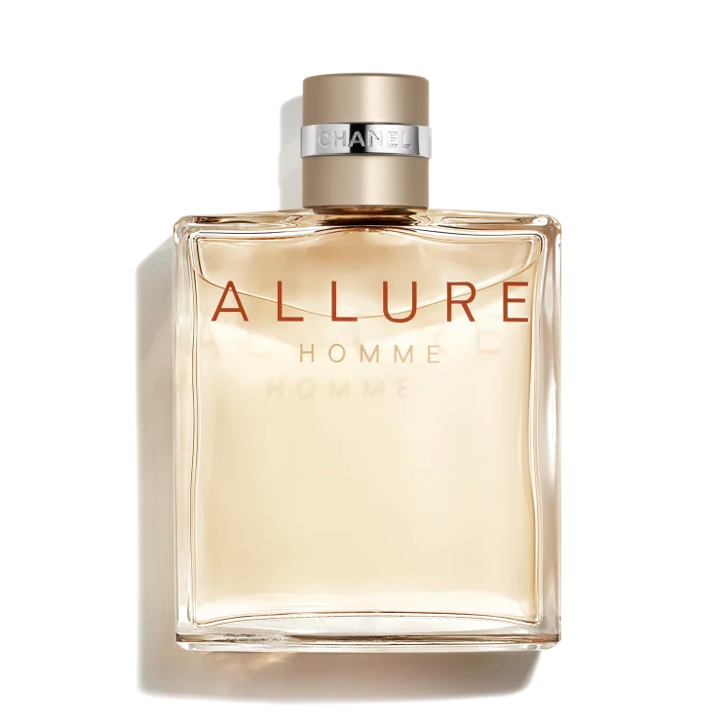

**ALLURE HOMME**

**$160**

Tax Included.

Spray 100 mL

IN STOCK

**Product Details**

Crisp and clean, warm and sexy, ALLURE HOMME is the expression of a man’s charisma and inner determination. A fresh, spicy and woody composition that reveals the presence of the man who wears it.

Vigorous, fresh top notes of bergamot blend into intense notes of vetiver. Venezuelan tonka bean and cistus labdanum combine for a sensual trail that’s heightened by notes of black pepper from Madagascar.